Amrita E-Learning Research Lab

A-VIEW 4.0 Server Installation Requirements

Amrita E-Learning Research lab

Amrita e-learning research lab

A-VIEW Server Installation Requirements

©Amrita E-learning Research Lab

Website: [www.aview.in](http://www.aview.in)

Phone: 0476.280.4431

Email: [aview@amrita.edu](mailto:aview@amrita.edu)

Table of Contents

|  |  |  |  |
| --- | --- | --- | --- |
| 1 | Software Requirements…………………………………………………………… | | 1 |
| 2 | Proprietary Software…………………………………………………………….. | | 1 |
| 3 | Free/Open Source Software………………………………………………………. | | 1 |
| 4 | OS Requirements…………………………………………………………………. | | 1 |
| 5 | Hardware Requirements………………………………………………………...... | | 2 |
|  |  | Deployment Scenario A Consolidated Configuration (Ubuntu)…..……….. | 2 |
|  |  | Deployment Scenario B Expanded Configuration (Ubuntu)………………. | 3 |
|  |  | Deployment Scenario A Consolidated Configuration (Windows)……...….. | 4 |
| 6 | Annexure 1: Required Ports & Protocols………………………………………… | | 5 |
| 7 | Annexure 2: Application Software Per License cost……………………………... | | 5 |
| 8 | Annexure 3: Server Pre-Requisites……………………………………...... | | 6 |
| 9 | Annexure 4: Configuration Instructions………………………………………….. | | 7 |

**Software Requirements**

This section describes the details of software that are required to run A-VIEW server. You are requested to select the appropriate version of the same according to your server OS type.

**Proprietary Software**

* Adobe Media Server Professional 5 64 bit
* Print2Flash Commercial 3.5[Server Mode] 64 bit
* MSOffice2010/2013 Professional or Enterprise Edition

The number of licenses depends up on the deployment scenario. A minimum of 1 license is required in any case. For approximate pricing details, refer licensing costs given in Annexure.1.

**Free/Open source Software**

A-VIEW Technical Support team will help install these as part of the setup/configuration process.

* Java JDK/JRE7.21
* .NET Framework 3.5SP1
* Adobe flash player plug-in & ActiveX
* Visual C++ redistributable x64
* SQLYog
* MySQL Server 5.5.16
* Adobe Reader 11
* Apache Tomcat 7.0.41
* Apache Web Server 2.4.2 with PHP5.4.3

**Operating System Requirements:**

The recommended OS type and versions are:

* Microsoft® Windows Server® 2008 R2 (64 bit) is required for Content Server. Application / Streaming Servers can also be deployed on Microsoft® Windows Server® 2008 R2 (64 bit).
* Ubuntu 12.04 / 14.04 LTS (64bit) can be used for Application / Streaming Servers.

**Hardware Requirements:**

A-VIEW Servers can be deployed in three different scenarios based on the load. If the number of simultaneous users accessing the service will be very high, we would recommend the second scenario.

**Deployment Scenario A: Consolidated Configuration (Ubuntu + Windows)**

The scenario is recommended for a limited number of concurrent users who will be accessing the service, causing a moderate load on the server.

Application / Streaming / Database server software and related services will be deployed in a single Ubuntu computer. The Content server will be deployed in a single Windows computer. As there is only server for each role, this configuration does not provide built-in failover capabilities.

|  |  |  |  |
| --- | --- | --- | --- |
| **Servers** | **Operating System** | **Hardware Specification** | **Number of instances** |
| **Video Server / Database Server / Web/Proxy Server** | Ubuntu 12.04 / 14.04 LTS 64bit | * 3.2-GHz Intel® Xeon® Quad Core processor, 32GB RAM, 2x1GB NIC * 1 TB or Higher SAN Storage OR Local SAS HDD (with RAID) | 1 |
| **Content Server** | Microsoft® Windows Server® 2008 R264bit | * 3.2-GHz Intel® Xeon® Quad Core processor, 8GB RAM, 2x1GB NIC * 1 TB or Higher SAN Storage OR Local SAS HDD (with RAID) | 1 |

**Deployment Scenario B: Expanded Configuration**

In this case services are deployed in multiple physical servers/ virtual machines. This scenario is recommended where a large number of concurrent users will be accessing the service, creating a high load on the server. This is also recommended when automatic failover support is desired. A rack/blade server array is recommended in this kind of scenario.

Below are the server hardware configurations for this scenario.

|  |  |  |  |  |
| --- | --- | --- | --- | --- |
| **Servers** | | **Operating System** | **Hardware Specification** | **Number of instances** |
| **Video Server** | Ubuntu 12.04 / 14.04 LTS 64bit | | * 3.2-GHz Intel® Xeon® Quad Core processor, 64GB RAM, 2x1GB NIC * 1TB or Higher SAN Storage / Local SAS HDD (with RAID) | 2 |
| **Content Server** | Microsoft® Windows Server® 2008R2 64bit | | * 3.2-GHz Intel® Xeon® Quad Core processor, 8GB RAM, 2x1GB NIC | 2 |
| **Database Server (Master-slave configuration)** | Ubuntu 12.04 / 14.04 LTS 64bit | | * 2 x 3.2-GHz Intel® Xeon® Quad Core processor, 8GB RAM, 2x1GB NIC * 1TB or Higher SAN Storage / Local SAS HDD (with RAID) | 2 |
| **Web/Proxy Server** | Ubuntu 12.04 / 14.04 LTS 64bit | | * 3.2-GHz Intel® Xeon® Quad Core processor, 8GB RAM, 2x1GB NIC * 1TB or Higher SAN Storage / Local SAS HDD (with RAID) | 2 |

**Deployment Scenario C: Consolidated Configuration (All-In-One Windows)**

The scenario is recommended for a limited number of concurrent users who will be accessing the service, causing a moderate load on the server.

Application / Streaming / Database server software and related services will be deployed in a single Ubuntu computer. The Content server will be deployed in a single Windows computer. As there is only server for each role, this configuration does not provide built-in failover capabilities.

|  |  |  |  |
| --- | --- | --- | --- |
| **Servers** | **Operating System** | **Hardware Specification** | **Number of instances** |
| **Video Server / Database Server / Web/Proxy Server/Content Server** | Microsoft® Windows Server® 2008 R264bit | * 3.2-GHz Intel® Xeon® Quad Core processor, 32GB RAM, 2x1GB NIC * 1 TB or Higher SAN Storage OR Local SAS HDD (with RAID) | 1 |

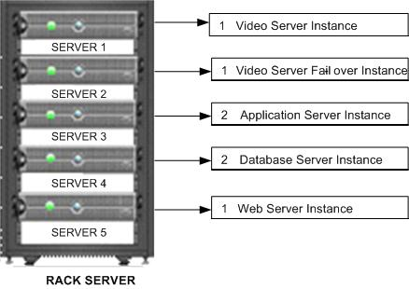

**Streaming Server**

**Content Server**

**Database Server**

**Web Server**

**Fail-Over Server**

**Multi Server Instances**

**Minimum Storage Requirement**

2TB SAN Storage with RAID5 (HP P4500 G2 / IBM SAN24B-4 Express / Equal Logic PS6500E iSCSI SAN Storage OR Similar)

**Annexure 1: Required Ports & Protocols**

**The following ports and protocols are required to run A-VIEW Server**

|  |  |
| --- | --- |
| **Protocols** | **Ports** |
| TCP | 80, 8080, 2605 |
| RTMP | 1935 |

**The following ports and protocols are required to run A-VIEW Client**

|  |  |
| --- | --- |
| **Protocols** | **Ports** |
| TCP | 80, 8080 |
| RTMP | 1935 |

**Annexure 2: Application Software per License cost**

**Application Software Per License Cost*.**

* Adobe Media Server Professional 564-bit - 2.8 Lakh INR
* Print2Flash Commercial 3.4 [Server Mode] 64-bit - 36,000 INR
* Microsoft Office 2010 Professional Plus 64 bit - 15,000 INR

**Optional Software**

* ISpringPowerPoint to Flash SDK 5.7.0 64-bit(Animation support during slide presentations)- 5,980 USD (3,22,920 INR) 2Developer + 2 Production Licenses

**\* The given cost is an approximation only. Prices may vary according to the license schemes and types.**

**Annexure 3: Server Installation Pre-Reqs**

## Special Server Setup for Windows Server

* Disable “Application Experience” Lookup Service
* Microsoft Visual C++ 2008 SP1 Redistributable Package (x64)
* Microsoft Visual C++ 2010 SP1 Redistributable Package (x64)
* Perform all security updates

## Content Server (Windows)

* Install the following software using the recommended versions given at the first section of this document:
  + Microsoft Office
  + Adobe Acrobat Reader
  + .NET Framework
  + Apache Web Server (Wamp)
  + ISpring (Optional)
  + Print2Flash

## Video Server / Collaboration Server

* Install the following software
  + Apache Web Server (Wamp)
  + AMS / FMS (disable the Http that comes with Fms)

## Application &Database Server

* Install the following software
  + Mysql
  + Java
  + Tomcat
  + Sqlyog Community Edition

**Annexure 4: Configuration Instructions**

**4.1 Video / Collaboration Server**

* Install the following software
  + FlashMediaServer4.5_x64.exe

During installation specify a password for administrator login. The ports need to be specified as given below.

ports: [1935,80]

admin port: [1111]

admin user: administrator

admin password: [PASSWORD]

default user: [administrator]

default group: [administrator]

install apache: NO

* Copy folders cloned from the GitHub (aview-video-fms) into applications folder of the FMS/AMS installed directory

**4.2 Application & Database Server**

**4.2.1 Mysql Configuration**

* Edit **my.ini** and add the following line under [mysqld] and [mysqldump]
* max_allowed_packet=100M

Create the database

CREATE DATABASE aview;

CREATE DATABASE aview_audit

* Create user and set permissions.

CREATE USER 'aview_app'@'localhost';

SET PASSWORD FOR 'aview_app'@'localhost' = '*A1297CD5E0976E65D9BB5F6B1E8C63CFBFF8BFE5';

GRANT SELECT ON aview.* TO 'aview_app'@'localhost';

GRANT INSERT ON aview.* TO 'aview_app'@'localhost';

GRANT UPDATE ON aview.* TO 'aview_app'@'localhost';

GRANT DELETE ON aview.* TO 'aview_app'@'localhost';

FLUSH PRIVILEGES;

GRANT SELECT ON aview_audit.* TO 'aview_app'@'localhost';

GRANT INSERT ON aview_audit.* TO 'aview_app'@'localhost';

GRANT UPDATE ON aview_audit.* TO 'aview_app'@'localhost';

GRANT DELETE ON aview_audit.* TO 'aview_app'@'localhost';

**4.2.2 Tomcat**

1. Set Automatic startup of the service for Windows

2. Configure it to use port 9080 for HTTP

3. Copy aview.war file from the Development environment to webapps folder of Tomcat

and restart the Tomcat service

**4.3 Content Server**

**4.3.1 Wamp (Apache Web Server)**

* Disable MySql that comes in this package
* Set Automatic startup of the service
* Change user account in service to Administrator
* Edit httpd.conf as follows

Options Indexes

#Require local

Allow from All

Listen 8080

ServerName localhost:8080

* Copy the folders cloned from the GitHub (aview-content-php) to www folder under the WAMP installed directory

**4.3.2 PHP (Content Server)**

* Edit php.ini and set the following parameters:.

max_execution_time = 300

max_input_time = 120

post_max_size = 100M

upload_max_filesize = 100M

**4.3.3 Print2Flash**

* Change the service user name to Administrator (for shared storage)
* Default Document Options:
  + Open the Print 2 Flash application.
  + Select the Options->Default Document Options menu
  + Uncheck all the check boxes, Set Back/Forward button combo boxes to ‘Off’, Skin combo to <no skin> as shown below
  + Click ok

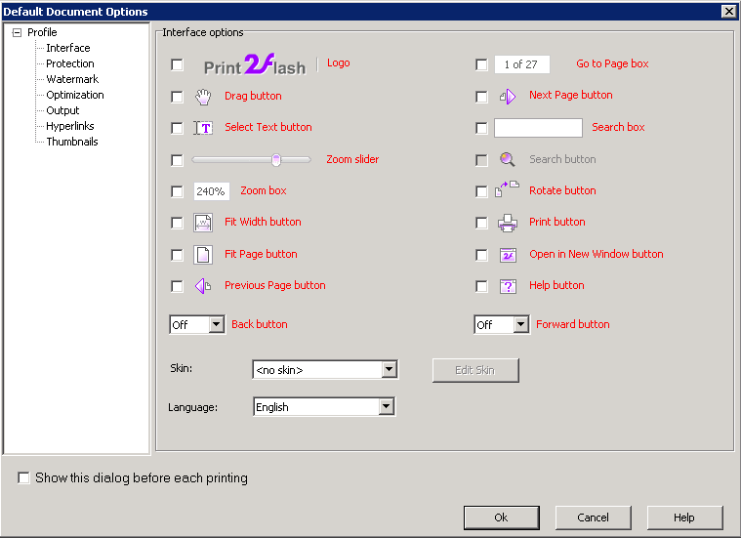

* + In Output: Single File Per page setup for AVIEW
* Set the license information
* P2F as Service: Install P2F service and setup to start automatically.
  + Use Administrator username
  + Grant Permissions to all.

**4.3.4 Speedtest (Optional)**

* Install speedtestmini.zip uncompress the file in /wamp/www/speedtest directory and rename index-php.html to index.html